**CHAPTER 4**

**PROPOSED SYSTEM**

As we can see in Existing system 2 there are cameras placed, theses cameras send surveillance feeds. This feeds can be given to a computer which can detect bike riders who are not wearing helmet as shown in figure 4.a. This system eliminates human intervention and automatically detects traffic rules violators and generates penalty tickets automatically with higher efficiency.

This section presents the proposed approach for real-time detection of bike-riders without helmet which works in two phases. In the first phase, we detect a bike-rider in the video frame. In the second phase, we locate the head of the bike-rider and detect whether the rider is using a helmet or not. In order to reduce false predictions, we consolidate the results from consecutive frames for final prediction. As helmet is relevant only in case of moving bike-riders, so processing full frame becomes computational overhead which does not add any value to detection rate. In order to proceed further, we apply background subtraction on gray-scale or black and white frames, with an intention to distinguish between moving and static objects.

Since there is no human intervention mistakes caused by human errors can be avoided. The system also detects triple riding which is against the traffic rules. This systems can also be implemented in ATMs.

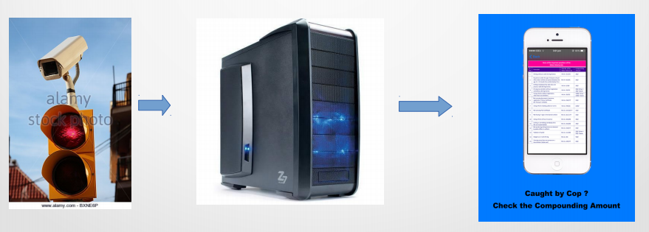

Fig 4.a